**DAILY ONLINE ACTIVITIES SUMMARY**

|  |  |  |  |  |  |  |  |  |
| --- | --- | --- | --- | --- | --- | --- | --- | --- |
| **Date:** | **23/06/2020** | | | | | **Name:** | **NIKHIL KUMAR** | |
| **Sem & Sec** | **4thSEM. & ‘B’ SEC.** | | | | | **USN:** | **4AL19CS400** | |
| **Online Test Summary** | | | | | | | | |
| **Subject** | | **NIL** | | | | | | |
| **Max. Marks** | | **NIL** | | **Score** | | | **NIL** | |
| **Certification Course Summary** | | | | | | | | |
| **Course** | **Solid fundamental HTML, CSS, JavaScript Course** | | | | | | | |
| **Certificate Provider** | | | **BitDegree** | | **Duration** | | | **5hr** |
| **Coding Challenges** | | | | | | | | |
| **Problem Statement1 :** Python Program to Split the array and add the first part to the end There is a given an array and split it from a specified position, and move the first part of array add to the end.  Examples:  Input : arr[] = {12, 10, 5, 6, 52, 36} k = 2 Output : arr[] = {5, 6, 52, 36, 12, 10} Explanation : Split from index 2 and first part {12, 10} add to the end .  Input : arr[] = {3, 1, 2} k = 1 Output : arr[] = {1, 2, 3} Explanation : Split from index 1 and first part add to the end.  **Problem Statement2 :** Write a C Program to Sort a stack using a temporary stack.  We follow this algorithm.   1. Create a temporary stack say tmpStack. 2. While input stack is NOT empty do this: • Pop an element from input stack call it temp • while temporary stack is NOT empty and top of temporary stack is greater than temp, pop from temporary stack and push it to the input stack • push temp in temporary stack 3. The sorted numbers are in tmpStack. | | | | | | | | |
| **Status: Executed** | | | | | | | | |
| **Uploaded the report in Github** | | | | | **Yes** | | | |
| **If yes Repository name** | | | | | 1. <https://github.com/Nikhil401/C-Coding/blob/master/split_array.py> 2. <https://github.com/Nikhil401/C-Coding/blob/master/Sort_Stack.c> | | | |
| **Uploaded the report in slack** | | | | | **Yes** | | | |

**Online coding summary: Today I got coding question which I have mentioned in above table, Snapshot is given belo**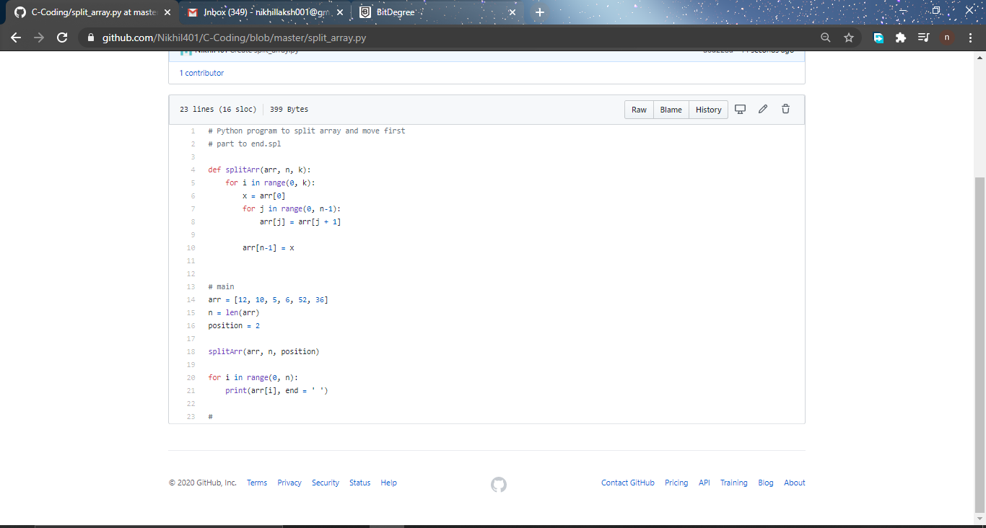

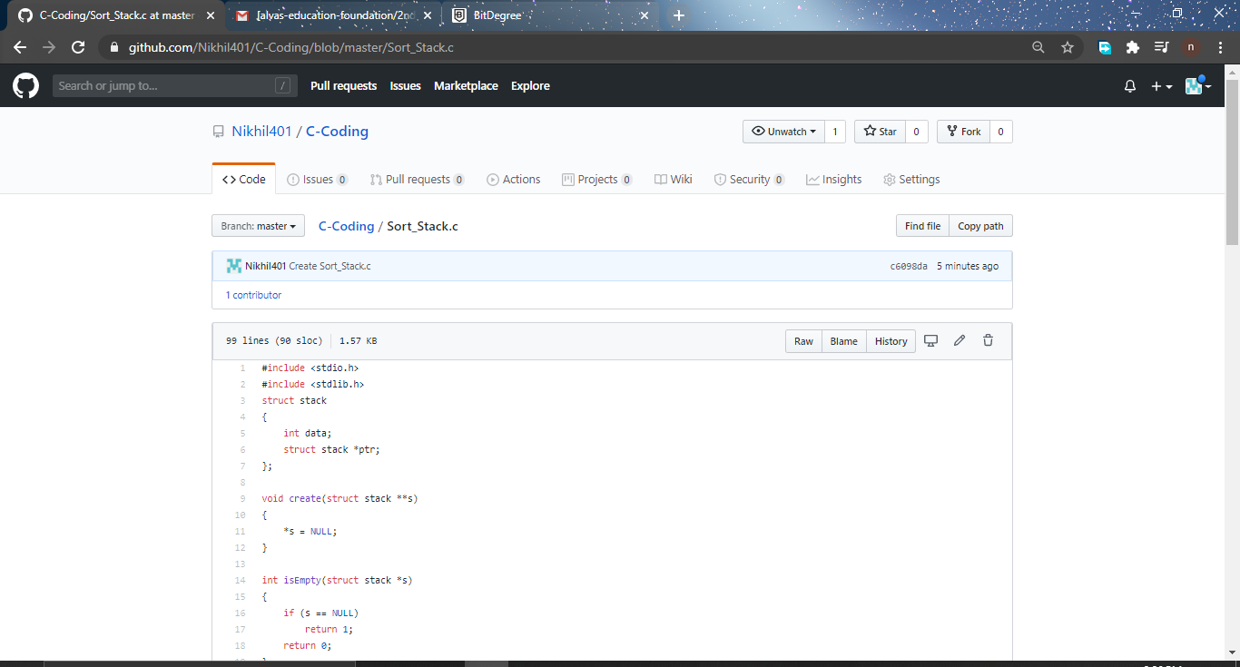

**Certification Course Summary: Today I have learnt about Historical overview, html 4.01, Head of the document , Document Body under the “ Solid fundamental HTML, CSS, JavaScript Course” and the snapshot is given below:**

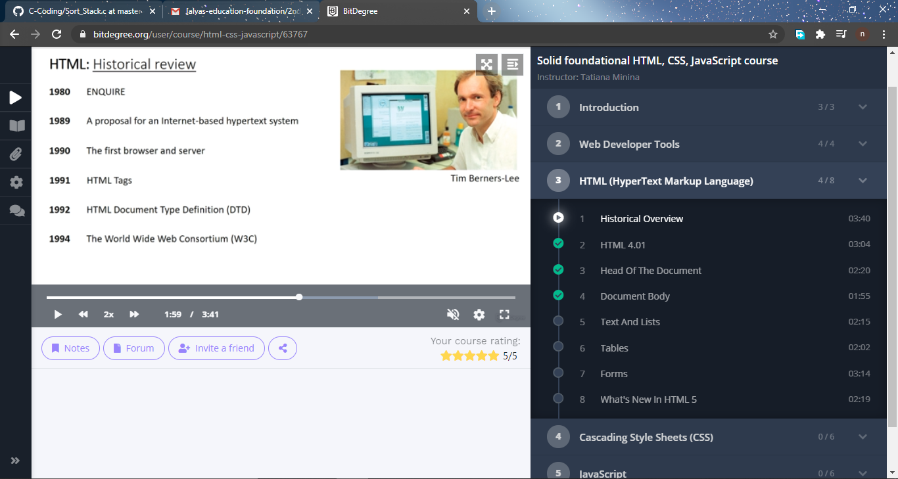**Thank you.**